

Teamcenter System Replication Guide v4.3

**Table of Contents**

Contents

Version History 3

Introduction: 3

Prepare Environment 3

Installation 4

Determining Teamcenter Version 5

Preparing the Environment 5

Database Backup/Export/Import 7

Prior to Export 7

After Export: 7

After Import: 9

Configuration Adjustments 10

Tc8.3 and prior: 10

Tc9.1 12

Validation 14

Logging Details 15

# Version History

|  |  |
| --- | --- |
| Version | Changes |
| v1 thru 3.1 | Replication steps up to and including Tc8.3. |
| v4.0 | Added Tc9.1 details  Added more direct steps for Oracle Added syntax steps for SQL Server |
| v4.1 | Added some details on the TC_DATA and BMIDE validation |
| **v4.2** | Added details for Tc10.1  Added Replace a server with a clone (Tc10.1)  Added Create environment for upgrade testing (Tc10.1) |
| **V4.3** | Modified to separate Tc8, Tc9 from Tc10 and above.  Separate Document created for Tc10.1 and above |

# Introduction:

**The Following Process Is Only Intended To Test The Deployment Of Your Data Model To Identify Issues Prior To Upgrading Your Production Environment.**

# Prepare Environment

Backup the following content:

* Determine the new location of the install (server(s) to be used
* Volume data (if storage is available)
  + In Tc9.1 or earlier you will need the dba volume (minimum requirement) for sure as it is required.
* Database dump / backup file
* Custom BMIDE project directory at pre-upgrade version
* Back up the current TC_DATA on the system you are starting with
  + Files may be needed from here for some custom files to be copied over to the new system:

# Installation

To properly test a replication for an upgrade or the like, you need to first build a generic test installation. This installation is going to be an out of the box installation of the version of the product you are looking to replicate. There are some things to remember:

* **As part of this procedure ensure you match up the features you installed on the source install to the new target install**

If you have an installation of Teamcenter with Foundation, TranslationService Change Management features (data model features) and RAC that you want to replicate on a new machine for upgrade or data model testing, the new target install will need to be that same features (data model templates) installed in the new system when you are done.

* **Install the data model templates**

If you have some customer template along with some template like feature_seec.xml then you need to install both of those in the target installation as well before starting the replication process.

* **Patches make a difference so don’t leave them out**

Ensure that you match up the path / MP level between the source and target installations as this can play a role as well. If your source system is Tc8.3.3.3 then you would need that same patch level applied before you begin the replication process of bringing over the database and volume data.

* **Validate the FMS configuration so that you can create and update data in the new target install before starting the replication process**

Without doing this, you can run the risk of starting with an incorrectly configured system and then have other issues to deal with on top of the changes required for system replication.

* **Be as consistent as possible, makes it smoother**

Try to match up things like SID names, OS / installing user accounts, password, installation directory structure, etc. If you can do this, then it will save re-work for things like the encrypted string for the TC_DB_CONNECT variable or mismatch in the database dump file between installations.

# Determining Teamcenter Version

To start, determine the major release you have. Is it Tc8.3? Tc9.1? In order to find out, you can run your current Rich Client. From there, you can choose Help-About-More. This should show you something like the image below.

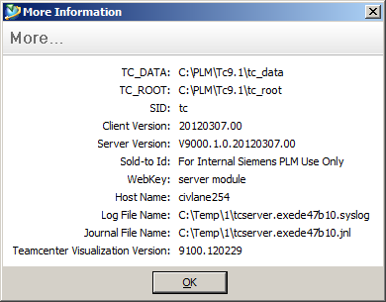

This gives you the version that is needed at the binary level, such as Tc9.1 in this case. Now you need to find out what features are installed to ensure the source and target systems are matching. To get this information, you need to go to the %TC_ROOT%\install directory on the server. Here you will find a file called configuration.xml which shows the current configuration details such as features and setting like ports, paths, etc. You can also run the TEM (Teamcenter Environment Manager) and it will list your installed features as well under the expandable tree for your configuration name.

# Preparing the Environment

When you start building the new server, you will want to replicate the solution listing in this file to minimize any inconsistencies in the two systems. This is critical for upgrade testing validation. Here is the simple list of the steps that would need to be followed for the initial destination or target server where the clone activities will be performed.

* 1. Download or stage the content for the initial installation of the Teamcenter product.
  2. Determine and install your database server software you plan to use.
  3. Complete the installation of the initial server.
     1. To minimize other changes, you should use the same database SID, OS username and password, database username and password, ports, etc.
  4. Add any other modules/features into the product to make the initial system match the source system.
  5. Determine if you have a BMIDE custom template. If so, then deploy the same version you have in place in the original installation into the initial server so that all data model settings are there.
  6. If you have requirements in your data model project that tie into the Organizational structure such as groups, roles, users, etc. then you will need to export those from the current system using the following syntax.
     1. plmxml_export -u=xxxxx -p=xxxxx -g=dba -xml_file=tc_person.xml -class=Person
     2. plmxml_export -u=xxxxx -p=xxxxx -g=dba -xml_file=tc_role.xml -class=Role
     3. plmxml_export -u=xxxxx -p=xxxxx -g=dba -xml_file=tc_group.xml -class=Group
     4. plmxml_export -u=xxxxx -p=xxxxx -g=dba -xml_file=tc_user.xml -class=User
     5. plmxml_export -u=xxxxx -p=xxxxx -g=dba -xml_file=tc_groupmember.xml - class=GroupMember
  7. To then import these into your clone installation, use the following from a Teamcenter shell or command prompt.
     1. plmxml_import -u=xxxx -p=xxxx -g=dba -xml_file=tc_person.xml
     2. plmxml_import -u=xxxx -p=xxxx -g=dba -xml_file=tc_role.xml
     3. plmxml_import -u=xxxx -p=xxxx -g=dba -xml_file=tc_group.xml
     4. plmxml_import -u=xxxx -p=xxxx -g=dba -xml_file=tc_user.xml
     5. plmxml_import -u=xxxx -p=xxxx -g=dba -xml_file=tc_groupmember.xml
  8. Apply any patches or MP’s that are in place in the source system.
  9. Verify that you can login successfully and create a dataset with a named reference. This will ensure that all is working prior to the start of the replication or clone process.
  10. Backup your configuration to make all of this process easier to reproduce later unless you want to repeat these steps as noted.
      1. Export the database
      2. Backup the volumes
      3. Export the preferences from the Teamcenter database
      4. Backup the template project
      5. Backup the %TC_DATA%/model directory
      6. Backup the %TC_ROOT%/install/configuration.xml (shows config details)
  11. To have the original settings for FMS from your initial system, run this command from a Teamcenter shell / command prompt and hang onto the file for reference to compare against the system after the database is imported.
      1. backup_xmlinfo –u=infodba –p=infodba –g=dba
  12. The file called backup.xml will be produced in the current directory from where the command prompt is in currently. This will show much valuable information for comparison after the import.

# Database Backup/Export/Import

*NOTE: If you are in a production installation, it would be a good idea to make sure and take two dump files in case the first is faulty or invalid. Better safe than sorry. Also, make sure that you are doing the dump and import processes during a downtime window where there are no active connections or users logged into Teamcenter. Active or idle sessions can cause locks in the database and you want to remove those with the clearlocks –assert_all_dead command from a Teamcenter shell before you start this process.

Consult you DBA for getting the database exports and imports performed. Reference GTAC Guide “Database Backup/Import/Export Guide”

For Oracle 10g/11g import and export can be processed using impdp and expdp

Once complete, there is the following step that needs to be done at three points:

## Prior to Export

Before you dump the database file, perform the following to get the current database string:

* **SELECT count(*) FROM PPOM_OBJECT;**

Store this value or image for reference as you will need to compare the other two results to ensure no modifications to the database occurred between the steps.

## After Export:

After the dump of the database, perform the following and hang onto the results for comparison. This is to verify that no data was created during the export:

* **SELECT count(*) FROM PPOM_OBJECT;**

Now that you have the dump file, you can go to another server and populate an empty Teamcenter database with it.

**Drop the current Teamcenter database from the test system: (on destination server)**

Navigate to the %ORACLE_HOME%\assistants\dbca\templates folder and you should find a file called tc_unpopulate_db.sql. You can call this from a regular command prompt:

set ORACLE_HOME=* set ORACLE_SID=*

cd %ORACLE_HOME%\assistants\dbca\templates sqlplus /nolog

connect /as sysdba

@tc_unpopulate_db.sql Example:

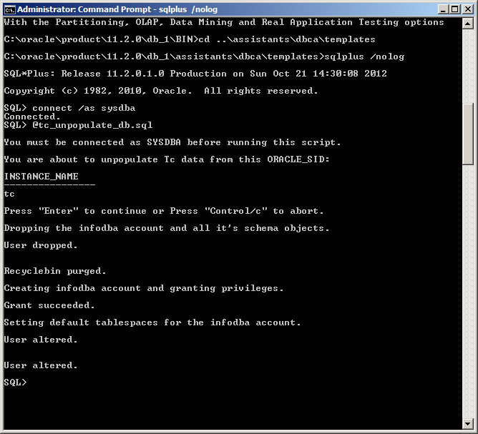

**Import the database into the test system:**

*NOTE: Ensure that your database properties/configuration are consistent between the Production database and the Test database.

*NOTE: If you use expdp then you must use impdp. If you use exp then you must use imp. Don’t mix and match the utilities.

## After Import:

After the dump of the database, perform the following and hang onto the results for comparison:

* **SELECT count(*) FROM PPOM_OBJECT;**

Compare the results from the three select statements. If the value returned for this is the same for all three then continue forward. If not, then re-export and run through the steps again making sure that there are no active connections to the database.

# Configuration Adjustments

First things first: After the import of the database, the new organizational structure and content will point to the source volumes and FSC’s. In this case, be aware and make sure that the first thing you do is to do the following:

## Teamcenter 8.3 and prior:

1. Open a Teamcenter shell / command prompt. Issue the following command:
   1. backup_xmlinfo –u=infodba –p=infodba –g=dba
2. Here, you can compare the backup.xml from this step to the backup.xml prior to the database import process.
3. Login with RAC as a DBA user.
4. Select Edit-Options-Search. Find and update the following database preferences to the new hostname.
   1. Fms_Bootstrap_Urls
   2. Default_Transient_Server
   3. Transient_Volume_Installation_Location
   4. Transient_Volume_RootDir
   5. Default_Transient_Volume_Id
5. Go to the Organization application

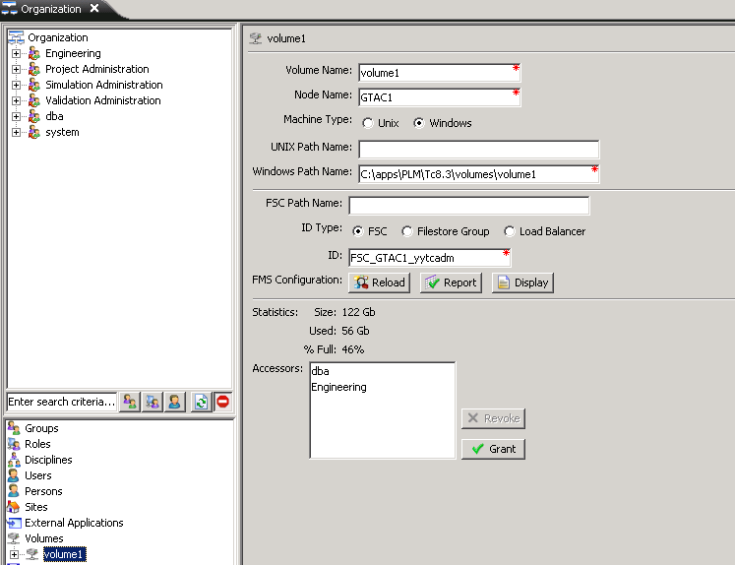

* 1. For each volume, update the nodename first and by itself in one action.
  2. Update the FSC ID value. Update the volume path (Win or Unix) in a second action.
     1. If the volumes are too large to use, create empty paths and point to those. This will allow for new data to be created while not giving access to existing metadata as no named reference data for that will be present.
     2. Once you hit modify and then click off and back onto a volume you may get an error. Correct each volume and then move on. The FMS update will resolve this issue.

1. While in the Organization panel, note the Sites section. Double click on Sites and select the site. Here will be the site ID. Note this value.

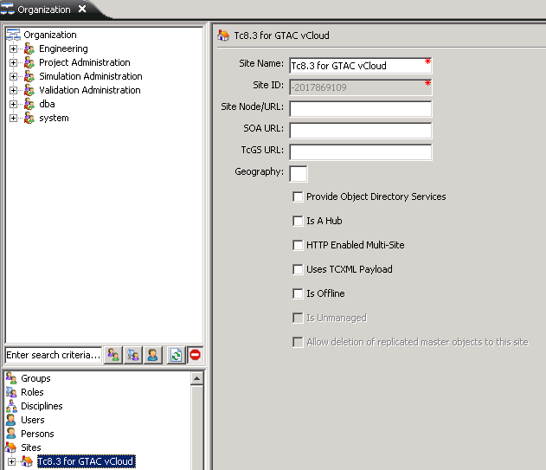

1. Open the %TC_ROOT%\fsc\fmsmaster_*.xml file. Find the attribute called ‘fmsenterpriseid’. From here, backup this file. Then, find and replace all instances of the numeric value for ‘fmsenterpriseid’ with the numeric value from the site ID. Save the file.
2. Update the transient volume values in the FMS master to match correctly for values from the database preferences.
3. From the server, run TEM.
4. Choose Configuration Management

--Continued Next Page--

1. Perform maintenance
2. Update FMS Master
   1. Go forward through the panels till you get to the panel called ‘Volume Query’.
   2. On this panel, select the ‘Scan’ button. There will be a prompt for the infodba account. Provide this input.

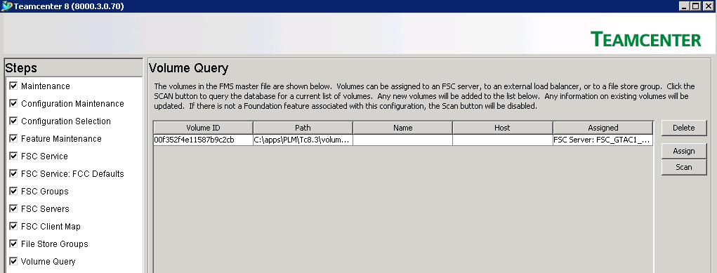

* 1. On the resultant screen, there will be a button for ‘OK’ to allow this to continue. Click ‘OK’.

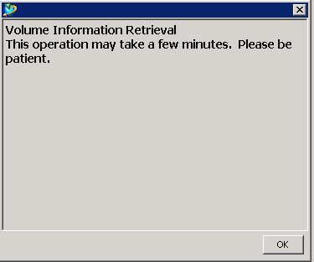

* 1. Ensure all volumes show the right hostname and are assigned to the right FSC.

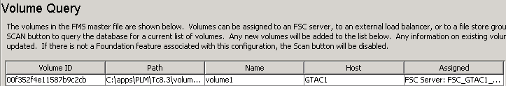

1. Following this, allow TEM to complete.
2. Restart the FSC(s) service that is configured as master. If you have other Non-Master FSC’s then you will need to restart those as well.
3. Kill any previous TcServer processes that are still running in the new cloned installation.
4. Try to login and create new data in RAC2t.

## Teamcenter 9.1

1. Open a Teamcenter shell / command prompt. Issue the following command:
   1. backup_xmlinfo –u=infodba –p=infodba –g=dba
2. Here, you can compare the backup.xml from this step to the backup.xml prior to the database import process.
3. Open the %TC_ROOT%\fsc\fmsmaster_*.xml file. Find the attribute called ‘fmsenterpriseid’. From here, backup this file. Then, find and replace all instances of the numeric value for ‘fmsenterpriseid’ with the numeric value from the site ID. Save the file.
4. Update the transient volume values in the FMS master to match correctly for values from the database preferences.
5. Bring over the dba volume from the source installation to the cloned system in the place of the default volume for the infodba account.
6. Update the volume id string from the cloned systems backup.xml file after the database import occurs to go into the FMSmaster xml file.
7. Login with RAC as a DBA user.
8. Select Edit-Options-Search. Find and update the following database preferences to the new hostname.
   1. Fms_Bootstrap_Urls
   2. Default_Transient_Server
   3. Transient_Volume_Installation_Location
   4. Transient_Volume_RootDir
   5. Default_Transient_Volume_Id
9. Go to the Organization application
   1. For each volume, update the hostname first and by itself in one action.
   2. Update the FSC ID value. Update the volume path in a second action.
      1. If the volumes are too large to use, create empty paths and point to those. This will allow for new data to be created while not giving access to existing metadata as no named reference data for that will be present.
      2. Once you hit modify and then click off and back onto a volume you may get an error. Correct each volume and then move on. The FMS update will resolve this issue.
10. From the server, run TEM.
11. Choose Configuration Management
12. Perform maintenance
13. Update FMS Master
    1. Go forward through the panels till you get to the panel called ‘Volume Query’.
    2. On this panel, select the ‘Scan’ button. There will be a prompt for the infodba account. Provide this input.
    3. On the resultant screen, there will be a button for ‘OK’ to allow this to continue. Click ‘OK’.
    4. Ensure all volumes show the right hostname and are assigned to the right FSC.
14. Following this, allow TEM to complete.
15. Restart the FSC service that is configured as master. If you have other FSC’s then you will need to restart those as well.
16. Kill any previous TcServer processes that are still running in the new cloned installation.
17. Exit the Rich Client.
18. Launch the Rich Client again.
19. Login as the infodba user.
20. Attempt to create new data.

# Validation

From here validate that data and metadata can be created.

To test real data creation, attempt to create a dataset and ensure that a named reference is attached to it and being created in the correct volume location. For example, create a new text dataset and populate that dataset with real text. If you can save, close and re-open the dataset to see your content then the save of both metadata and named reference data is occurring.

In order to test the transient volume functionality, you can perform the follow actions from RAC.

1. Tools-Reports-Report Builder Reports
2. Of the reports, pick the “Admin - Group/Role Membership” report
3. For Group pick dba.
4. For Role, leave it blank.
5. For “Report Display Locale” use English.
6. For “Report Stylesheets” use “admin_group_role_html.xsl”
7. Click Finish.
8. The output of that report should look similar to this:

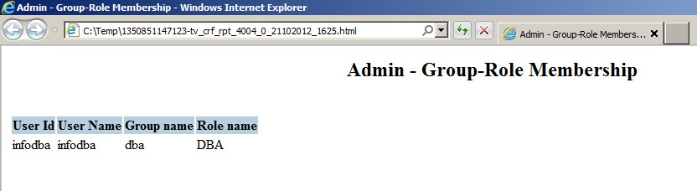

Do this action from 2Tier as well as 4Tier (if you are using 4Tier) and verify it works. If there is a failure then there is a problem with the transient volume ID and/or path in the following:

* Fmsmaster*.xml
* Database preferences
* *fcc.xml could also be pointing to the wrong FSC. Check this against the fmsmaster*.xml

To validate the data model functionality, then use TEM to cold deploy the current version of the customer specific template(s) to confirm that they deploy with no issues.

# Logging Details

The logging in FMS is located in the following path by default:

%TC_ROOT%\fsc\logs\fsc\process

If you don’t find a log file in this location then go to the following file:

%TC_ROOT%\fsc\FSC_*.xml

***Note****: In this file, note line 17 or the property name “FSC_LogFile”. If you want to point it to another location then you can modify the path from “” to “Path\to\log\file\directory” and restart the FSC service*

%TC_ROOT%\install\Install log

%TC_ROOT%\install\Configuration.xml

%TC_ROOT%\logs\